**LI CONTINUUM OF CARE MONTHLY NEWSLETTER**

**ISSUE**

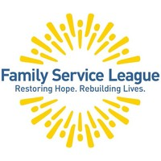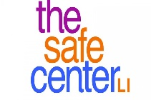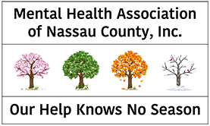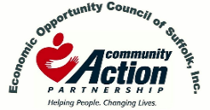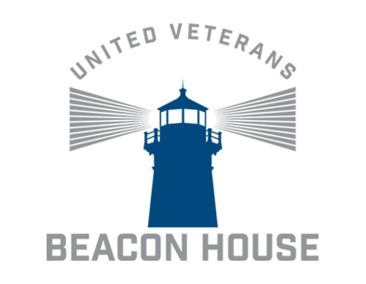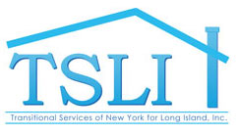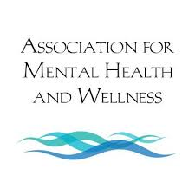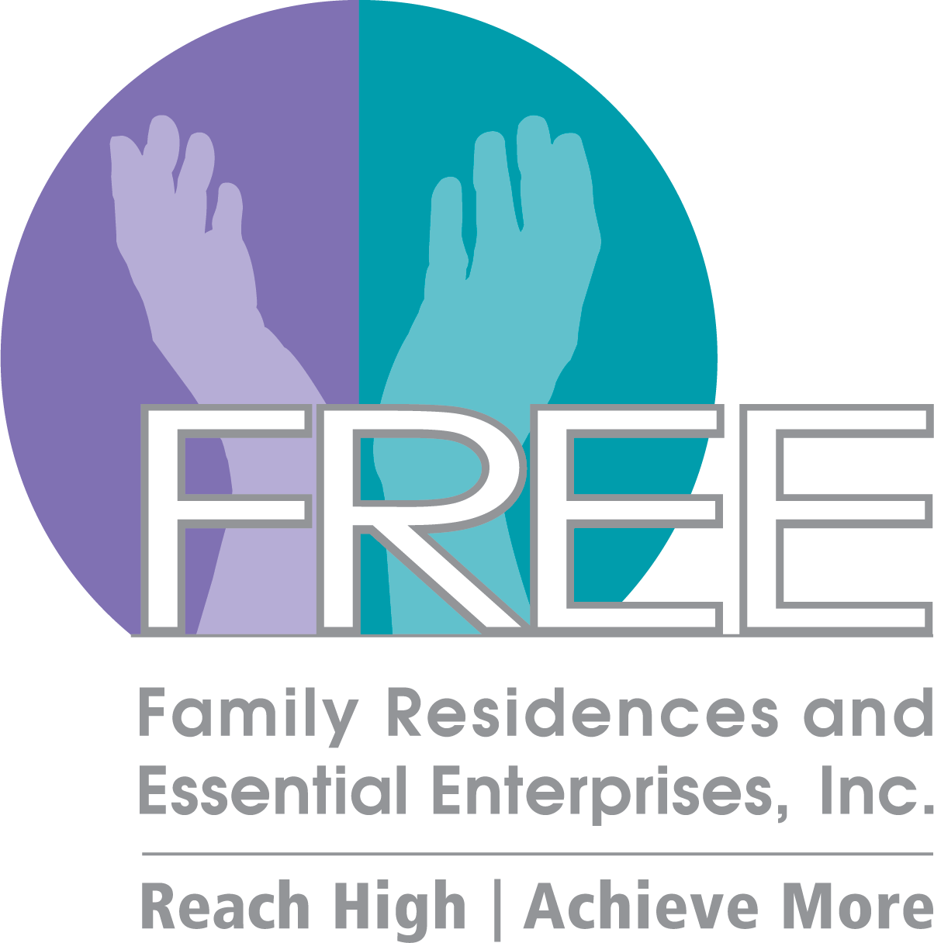 

**\*March 20th, April 17th, August 14 – Governance Board Meeting Only\***

**2020 CoC Schedule**

JUL17

*AUG 14

SEP 25

OCT 16

NOV 20

DEC 18

JAN 17

FEB 21

**\*MAR 20**

*APR 17

MAY 15

JUN 19

**Announcements**

* The **CoC Business and Community Response Forum Meetings** will be CANCELLED for this month as a precaution to large group gatherings
* The **March 20th CoC Governance Board Meeting** will STILL TAKE PLACE at the normally scheduled time of 10:30 AM to 11:45 AM. We will be sending instructions on how to join the meeting virtually through Web-Ex
* The **April 17th CoC Business and Community meeting** will also be cancelled, following the latest CDC guidelines of no gatherings of more than 50 people for the next 8 weeks.
* **Have a Heart for the Homeless: Candlelight Vigil** event on March 17, 2020 is CANCELLED and will be RESCHEDULED in the summer or fall 2020
* The **CoC website** - lihomeless.org has a comprehensive list of resources pertaining to COVID-19 for people experiencing homelessness and their homeless service providers. *This will be updated regularly!*
* All meetings will have the option to call in via **conference call line**, Web-Ex, or Zoom (until further notice)
* **The 2020 Census is NOW OPEN** - The results of the 2020 Census will help determine how hundreds of billions of dollars in federal funding flow into communities every year for the next decade. That funding shapes many different aspects of every community, no matter the size, no matter the location.
  + <https://2020census.gov/en.html>

**\*\*\*Please visit lihomeless.org for additional updates**

**\*DISCLAIMER: Undisplayed organizational logos could not be found online**

**MAR 2020**

*insert text*

**02ioo**

**Upcoming Webinars/Trainings**

1. Long Island CoC MATCH Training

* **Date:** March 18, 2020 9:30 AM -11:00 AM
* **Registration Link:** [https://tacinc.adobeconnect.com/longislandcocreg/event/event_info.html](https://nam12.safelinks.protection.outlook.com/?url=https%3A%2F%2Ftacinc.adobeconnect.com%2Flongislandcocreg%2Fevent%2Fevent_info.html&data=01%7C01%7Ctpham%40addressthehomeless.org%7Ce825b3b3dd92432df00e08d7bebc45cb%7Cf51f2c5ee8a74a2e83b60dcd7fc3081f%7C0&sdata=pD9XtYirHIcSNB2ByOuErpC6VUAb5nUPb%2BE1AhJNAlQ%3D&reserved=0)

1. Infectious Disease Preparedness for Homeless Assistance Providers and Their Partners

* **Date**: Can view anytime!
* **Registration Link:** <https://www.hudexchange.info/trainings/courses/infectious-disease-preparedness-for-homeless-assistance-providers-and-their-partners/>

1. Working Effectively with LGBTQ Residents 9:00 AM – 4:00 PM

* **Date: June 24, 2020**
* **Registration Link:** <https://events.r20.constantcontact.com/register/eventReg?oeidk=a07egxc4vjx634f43f8&oseq=&c=&ch=>

1. Understanding Opioid Use and Effective Shelter Staff Response

* **Date:** June 25, 2020 9:00 AM – 12:30 PM
* **Registration Link:**

<https://events.r20.constantcontact.com/register/eventReg?oeidk=a07egxc4vjx634f43f8&oseq=&c=&ch=>

1. HUD will be posting information on an upcoming webinar, tentative for 4/20 or 4/21 that will address racial equity using Coordinated Entry

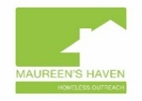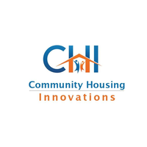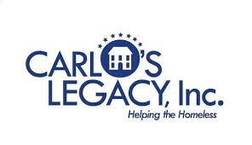

**Committee Updates**

**Racial Equity Committee**

* Thank you for attending our first meeting on 2/12/20!
* Next Meeting: TBA
* Check out this article! Of Colors Black History Exhibition & Diversity Celebration hosts prominent black leaders
  + <http://www.longislandadvance.net/stories/of-colors-black-history-exhibition-diversity-celebration-hosts-prominent-black-leaders,85262>
* Read more about Sherrilyn Ifill, Resident and Director-Counsel of the NAACP Legal Defense and Educational Fund, Inc.
  + <https://www.naacpldf.org/about-us/staff/sherrilyn-ifill/>
* Check out this article!
  + <https://www.opportunityhome.org/related-sectors/civil-rights-housing/>
  + Decide during this time of self-quarantine, to reflect on how not to continue to contribute to the racial equity and put one thing in action in your own life to create that racial equity value.
  + Due to policies and practices in both the public and private sectors, affordable housing for low-income households is often unavailable in desirable areas, which contributes to racial residential segregation.  The real work is reporting, speaking out and doing something about it when it shows up anywhere.
  + Racial inclusive, mixed-income neighborhoods benefit everyone.  Residents of diverse neighborhoods are able to interact on a daily basis – they harbor less prejudice and racial stereotypes, can better handle diverse working environments, are more culturally sensitive, and have more expansive social networks.

**Youth and Young Adult Services Committee**

* Please visit <https://youthcollaboratory.org/> for resources and upcoming webinars
* Please visit our lihomeless.org website for our comprehensive youth and young adult resource guide! <https://www.lihomeless.org/youth-young-adult-committee>
* School closures in Nassau County and Suffolk County are in effect from March 16th through March 27th.
* *What is the larger implication for youth and young adult homelessness? How does a parent who doesn’t get paid leave, adequately ensure the safety of their child?*
  + Parents will have to take off from work to watch their children during usual school times. This could have the repercussions of a lack of steady income to provide for basic needs (food, clothing, housing) and possibly no guarantee of a job upon return. Parents will have to employ a babysitter or nanny to supervise their children. This will provide a financial burden to individuals who may already be facing financial insecurity.
* During the time of mandated school closures from Nassau County Executive, Laura Curran, and Suffolk County Executive, Steve Bellone, these important liaisons and other supportive staff, such as guidance counselors, social workers and teachers, become unable to be a point of contact and support.

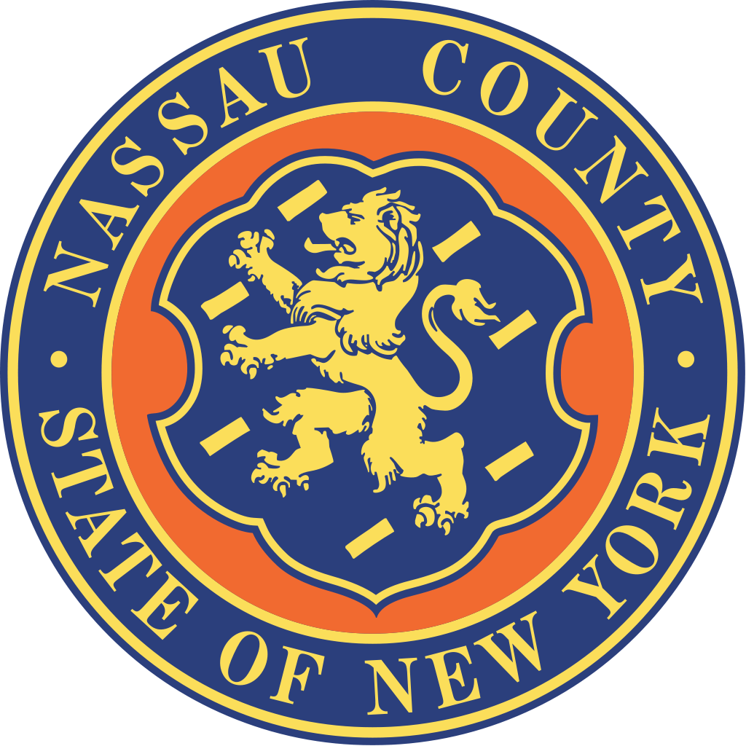



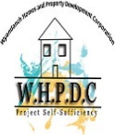

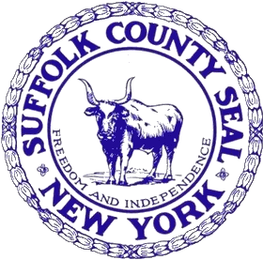



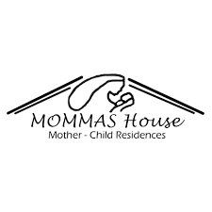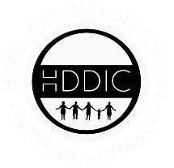

Suburban Housing

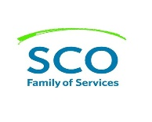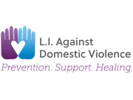

**CoC Updates (Business Meeting)**

* **2019 Funding Round**
  + HUD Tier 2 awards were announced on 3/13/20 and were sent out by Greta to the full CoC via email.
  + Overall, our CoC was awarded over $1.1 million in new PSH programs, as well as new planning and DV Bonus funding. The region was awarded a total of $13.7 million in federal funding for CoC programs.
* **2020 Funding Round**
  + All CoCs had to register for the 2020 Funding Round by 3/5/20.
  + The Ranking Committee has finalized the 2020 Ranking Committee scorecard for CoC renewal programs* and is in the process of finalizing a new, more detailed, scorecard for new applicants. *Please note changes to the RRH scoring measures. PSH measures remain the same as from the 2019 Funding Round.
  + The CoC is anticipating $1.5 million available in new funds through voluntary reallocation, as well as new Bonus funds and DV Bonus funds.
  + A MATCH training will be held as a live webinar this Wednesday, March 18 from 9:30am-11:00am. This training will be recorded and posted on the CoC website.
* **HUD Reporting**
  + HUD HDX is now open to submit HIC and PIT reports. As reviewed at the February CoC Business meeting, the total regional numbers have decreased for the fourth consecutive year.
  + HUD System Performance Measures were submitted on 2/28/20. Average length of time homeless has decreased for the third consecutive year.
* **CES Updates**
  + February and March have been great months for clients to move into housing (through the CoC and non-CoC housing opportunities)
  + Case conferencing has been an amazing opportunity to get together with other providers to discuss resources that both LICH and others have not been tapping into previously
  + Community Solutions Built For Zero Learning Sessions for April will still occur as remote online presentations. BFZ members will present on updates and best practices from around the country.
* **Street Outreach**
  + LICH will be conducting a drive for sanitary items to ensure the cleanliness and health of those on the street (TBA)
* **HMIS Updates**

*A Note About HMIS Data Quality During These Times of Change and Uncertainty:*

* + These are difficult and uncertain times for all of us on Long Island, in our country, and beyond.  Personal safety, the safety or our families, and the safety of all those within our communities is of paramount importance right now.  With that, the most vulnerable in our region continue to require the housing and services provided by the agencies dedicated to serving the homeless and those in need in our region.
  + Continuing to accurately reflect the active roster of your housing programs in our HMIS is as important now as it has ever been.  We know however that changes to normal program operations and staffing concerns may impact a program’s ability to keep up with the demands of timely HMIS data entry.
  + As we move forward, we ask that if you are having difficulty or are unable to keep up with your program’s new HMIS intakes and discharges, to please send us a note indicating that.  It’s important that we at the Long Island Coalition for the Homeless, as the HMIS Lead and CoC Lead for Nassau and Suffolk counties, understand the state of our HMIS data quality so we can continue to use the data to make housing and intervention decisions with our clients.

ADD/ADHD Housing Group INC.

**Peace Valley Haven**