**LI CONTINUUM OF CARE MONTHLY NEWSLETTER**

**ISSUE**

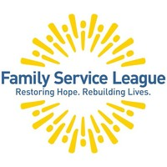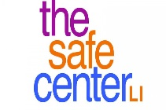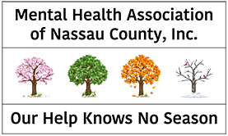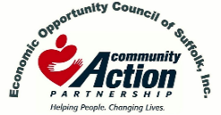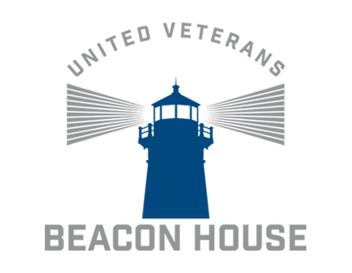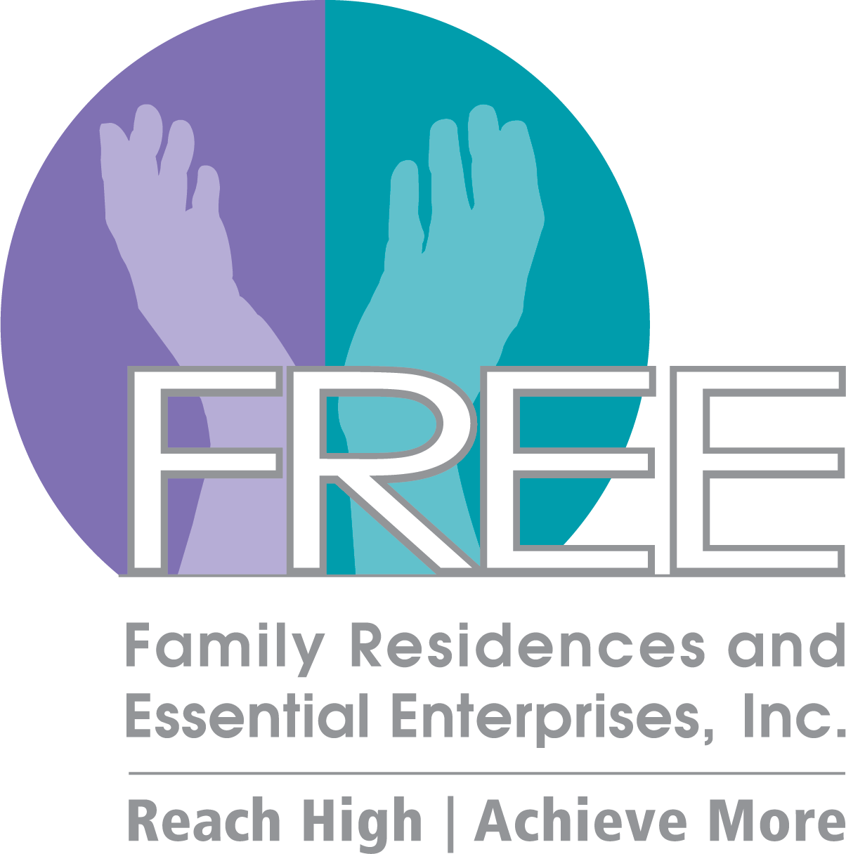

**05ioo**

**\*DISCLAIMER: Undisplayed organizational logos could not be found online**



**REOPENING STATUS FOR LONG ISLAND**

* PHASE 3: Restaurants/Food Services, Personal Care – June 24th
* PHASE 4: TBA/TBD ANTICIPATED JULY 8TH

**COVID-19 TESTING**

* <https://coronavirus.health.ny.gov/find-test-site-near-you>

**QUARANTINE RESTRICTIONS ON TRAVELERS ARRIVING IN NY**

* <https://www.governor.ny.gov/news/no-205-quarantine-restrictions-travelers-arriving-new-york>

**Announcements**

* The **CoC Business Meeting will resume virtually. Our next meeting will take place on July 17.** Please refer to the CoC Newsletter and emails for monthly updates.
* The **CoC website** - **lihomeless.org** has a comprehensive list of resources pertaining to COVID-19 for people experiencing homelessness and their homeless service providers. There is also a list of food pantries which is updated regularly.
* All meetings will be online through WebEx or conference call line
* **The 2020 Census is NOW OPEN** - The results of the 2020 Census will help determine how hundreds of billions of dollars in federal funding flow into

communities every year for the next decade. That funding shapes many different aspects of every community, no matter the size, no matter the location.

* + <https://2020census.gov/en.html>
* The 32nd Annual Keys for the Homeless Conference will be November 18th (Virtual Event)
  + We are requesting workshop proposals! Deadline for proposals is July 31st Please email [ymann@addressthehomeless.org](mailto:ymann@addressthehomeless.org) and [gguarton@addressthehomeless.org](mailto:gguarton@addressthehomeless.org)

**\*\*\*Please visit lihomeless.org for additional updates (food resources, testing centers, funding opportunities, training information, service provider resources, etc.)**

* <https://www.lihomeless.org/>
* <https://www.lihomeless.org/covid-19>
* <https://www.lihomeless.org/covid-19-hud-ta-and-local-guidance>

**JUNE 2020**

**2020 CoC Schedule**

**\*March 20th, April 17th, August 14 – Governance Board Meeting Only\***

**JUL 17**

*AUG 14

SEP 25

OCT 16

NOV 20

DEC 18

JAN 17

FEB 21

*MAR 20

*APR 17

MAY 15

JUN 19

*insert text*

**HUD TECHNICAL ASSISTANCE AND GUIDANCE**

* + <https://www.lihomeless.org/covid-19-hud-ta-and-local-guidance>

**Availability of Waivers of Community Planning and Development (CPD) Grant Program and Consolidated Plan Requirements to Prevent the Spread of COVID-19 and Mitigate Economic Impacts Caused by COVID-19**

* + [**https://files.hudexchange.info/resources/documents/Availability-of-Waivers-of-CPD-Grant-Program-and-Consolidated-Plan-Requirements-to-Prevent-the-Spread-of-COVID-19-and-Mitigate-Economic-Impacts-Caused-by-COVID-19.pdf**](https://files.hudexchange.info/resources/documents/Availability-of-Waivers-of-CPD-Grant-Program-and-Consolidated-Plan-Requirements-to-Prevent-the-Spread-of-COVID-19-and-Mitigate-Economic-Impacts-Caused-by-COVID-19.pdf)

**Availability of Additional Waivers for Community Planning and Development (CPD) Grant Programs to Prevent the Spread of COVID-19 and Mitigate Economic Impacts Caused by COVID-19**

* + <https://www.hud.gov/sites/dfiles/CPD/documents/Additional_Waivers_for_CPD_Grant_Programs_to_Prevent_COVID-19_Spread_and_Mitigate_COVID-19_Economic_Impacts.pdf?utm_source=HUD+Exchange+Mailing+List&utm_campaign=0a4b21aecc-COVID-19-Waiver-HOPWA-5.27.20&utm_medium=email&utm_term=0_f32b935a5f-0a4b21aecc-19249601>

**CoC Program Expedited COVID-19 Grant Agreement Amendments**

* + <https://www.hudexchange.info/programs/coc/covid-19-grant-agreement-amendments/>

**Local Field Office Email**

* + [CPD_COVID-19AmendmentNY@hud.gov](mailto:CPD_COVID-19AmendmentNY@hud.gov)

**HUD COVID-19 Office Hours Every Friday 2:30PM-4:00PM**

* + <https://www.hudexchange.info/news/office-hours-covid-19-planning-response-for-homeless-assistance-providers-fridays/>

**ESG Substantial Amendment Posting by OTDA**

* + <https://26605804-0f06-4f4c-9978-7cc160da7c9d.filesusr.com/ugd/22798f_c9c162206a1640358a13124becb876ea.pdf>

**FUNDING OPPORTUNITIES**

**Local CoC Application**

* Due to COVID-19, it is unclear when HUD will release its COC NOFA or what this year’s funding round will look like. However, we know that there will funds available for reallocation (assuming HUD allows reallocation this year). The Long Island Continuum of Care is releasing its LOCAL funding round applications. After discussions with the full COC and the Governance board, it was agreed that we will release the full applications, with an abbreviated version of REQUIRED questions (highlighted herein) but including all questions that had originally been included in the application
* APPLICATIONS (and attachments) FOR THE LOCAL PROCESS ARE DUE **JULY 27, 2020**
  + 2020 CoC LI Application Instruction can be found on our CoC Website
    - <https://www.lihomeless.org/coc-nofa>

**NYS UPDATES**

**Executive Orders**

* Website <https://www.governor.ny.gov/executiveorders>

**Eviction Moratorium**

* No 202.8 (Original)
  + <https://www.governor.ny.gov/news/no-2028-continuing-temporary-suspension-and-modification-laws-relating-disaster-emergency>
* No 202.28 (Extension – August 20th)
  + <https://www.governor.ny.gov/news/no-20228-continuing-temporary-suspension-and-modification-laws-relating-disaster-emergency>

**Tenant Safe Harbor Act**

* <https://www.nysenate.gov/newsroom/press-releases/brad-hoylman/tenant-safe-harbor-act-sponsored-senator-brad-hoylman-signed>
* <https://www.nysenate.gov/legislation/bills/2019/s8192/amendment/b>

**New York Forward (Industry Guidance, Reopening, Region by Region Status)**

* <https://forward.ny.gov/>

**Upcoming Webinars/Trainings**

1. **COVID-19 Response Meetings** 
   1. Every week/Every 2 weeks to discuss the planning and response in our region
   2. Updates on shelters, funding and supports for CoC and providers, resource sharing, etc
   3. Next meeting: June 5, 2020 at 10AM (WebEx Details Sent via Email)
2. **COVID-19 Office Hours Every Friday from 2:30PM-4:00PM**
   1. <https://www.hudexchange.info/news/office-hours-covid-19-planning-response-for-homeless-assistance-providers-fridays/>
3. **Keys for the Homeless Conference** 
   1. Anticipated virtual event for Fall 2020
   2. A survey will be sent out to assist with the planning of the event
      1. Workshop/Training Topics
      2. Suggestions for Trainers/Presenters
      3. The survey will also have questions pertaining to trainings you and your agency would like to see for the CoC

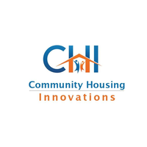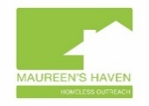

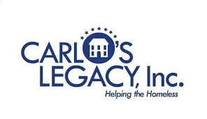









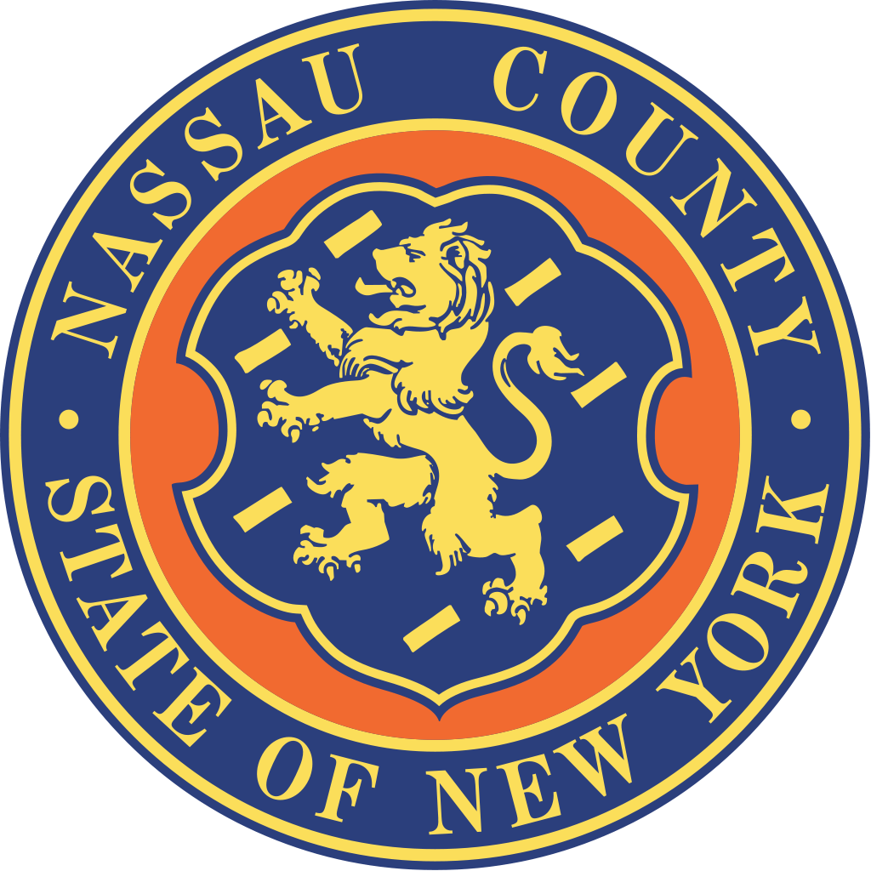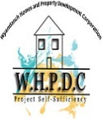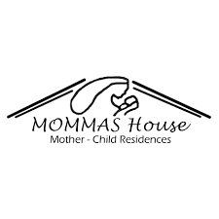

Suburban Housing



ADD/ADHD Housing Group INC.

**CoC Updates (General)**

**HMIS Updates**

* COVID-19 Awareness Screening Tool
  + Please continue to use (strongly encouraged)
* HMIS New User Trainings
  + July training for new users TBA
* Emails/Inquiries
  + Please refer to [wscallon@addressthehomeless.org](mailto:wscallon@addressthehomeless.org) for all HMIS inquiries during this time

**Coordinated Entry System (LICH)**

* Focused on re-examining the CE process
  + Reassessing the DV CE System
  + What is our role in racial equity?
* Staff is cautiously meeting with clients
  + Conducting COVID-19 screenings
* Updates
  + Next Rapid Rehousing Meeting June 25th at 11 AM - discuss challenges, COVID resources, etc.
  + CES case conferencing will continue in the near future

**Coordinated Entry System (TSCLI)**

* Working closely with TAC to improve overall operations of DV CES
* Please continue making referrals to the CE team
  + Referrals are still being made and VI-SPDATS, case management is provided to clients on the waitlist

**Committee Updates**

* **Racial Equity Committee**
  + **NEXT MEETING: July 8th from 7PM to 8PM**, Please register via email by July 6th DEADLINE to [tpham@addressthehomeless.org](mailto:tpham@addressthehomeless.org) Space is limited, only those who register will receive a link to the zoom! This meeting will be moderated by 2 of our staff members at Long Island Coalition for the Homeless: Edna White, Landlord Engagement Specialist and Thanh Pham, Community Outreach and Support Specialist. The goal of this committee is to educate, build awareness, and hold each other accountable towards our actions and words. Because as Housing Providers on Long Island, we recognize that the rooted structural racism impacts where you get to live and impacts every aspect of life. This is NOT your traditional sit down and listen meeting and we will be having thought provoking conversations and participating in a hands on activity together! The theme/topic for this meeting is focused on Housing Discrimination and Housing Discrimination Laws.
* **Webinar Opportunities** 
  + July 20th from 7PM-8PM: National Book Award winner and New York Times bestselling author Ibram X. Kendi discusses "How to Be an Antiracist"
    - <https://www.eventbrite.com/e/ibram-x-kendi-on-how-to-be-an-antiracist-tickets-110866502694?fbclid=IwAR10j8TfAq8WKVh6gDpeP1ZLFBP0Ar6-Gpul13FqMMhdPYnYANfUlRflkPw>
  + (Past Event – Recorded) The Other Pandemic: Systemic Racism and The Impact of the COVID-19 Crisis on Communities of Color on Long Island – A Virtual Town Hall
    - [https://www.youtube.com/watch?v=zt0j8GYdUJA](https://nam12.safelinks.protection.outlook.com/?url=https%3A%2F%2Fwww.youtube.com%2Fwatch%3Fv%3Dzt0j8GYdUJA&data=02%7C01%7Ctpham%40addressthehomeless.org%7C801f0c9a947646b5ef7508d816b5ae02%7Cf51f2c5ee8a74a2e83b60dcd7fc3081f%7C0%7C0%7C637284316846384798&sdata=22icSgRw6nf9FlDBtRqHg9JWqzBhdUGMEqtT2OPwiyo%3D&reserved=0)
  + A Path to Reproductive Justice: Research, Practices, and Policies
    - <https://apha.org/events-and-meetings/apha-calendar/webinar-events/2020/racial-equity-part-2>
  + (Past Event – Recorded) Advancing Racial Equity in the Fight to End Homelessness
    - <https://housingalliancepa.org/webinar-advancing-racial-equity-in-the-fight-to-end-homelessness/>
* **Legislation** 
  + **NYS Police Reform and Reinvention Collaborative 6/12/20**
    - <https://www.governor.ny.gov/news/no-203-new-york-state-police-reform-and-reinvention-collaborative>
  + **Declaring Juneteenth as a Holiday for NYS Employees 6/17/20**
    - <https://www.governor.ny.gov/news/no-204-declaring-juneteenth-holiday-new-york-state-employees>
  + **Senate Majority Advances Policing Reforms Legislative Package 6/6/20**
    - <https://www.nysenate.gov/newsroom/press-releases/senate-majority-advances-policing-reforms-legislative-package?fbclid=IwAR0SAHvp_fFEc8a3zOt7osGyeUdEbIMcLEx9g7Ehzt0cmhuSKLhQ4Vh7qOU>

**Peace Valley Haven**