**LI CONTINUUM OF CARE MONTHLY NEWSLETTER**

**ISSUE**

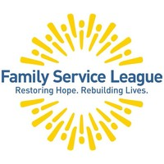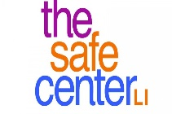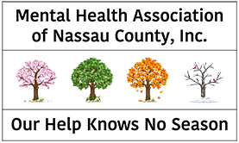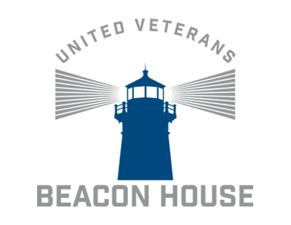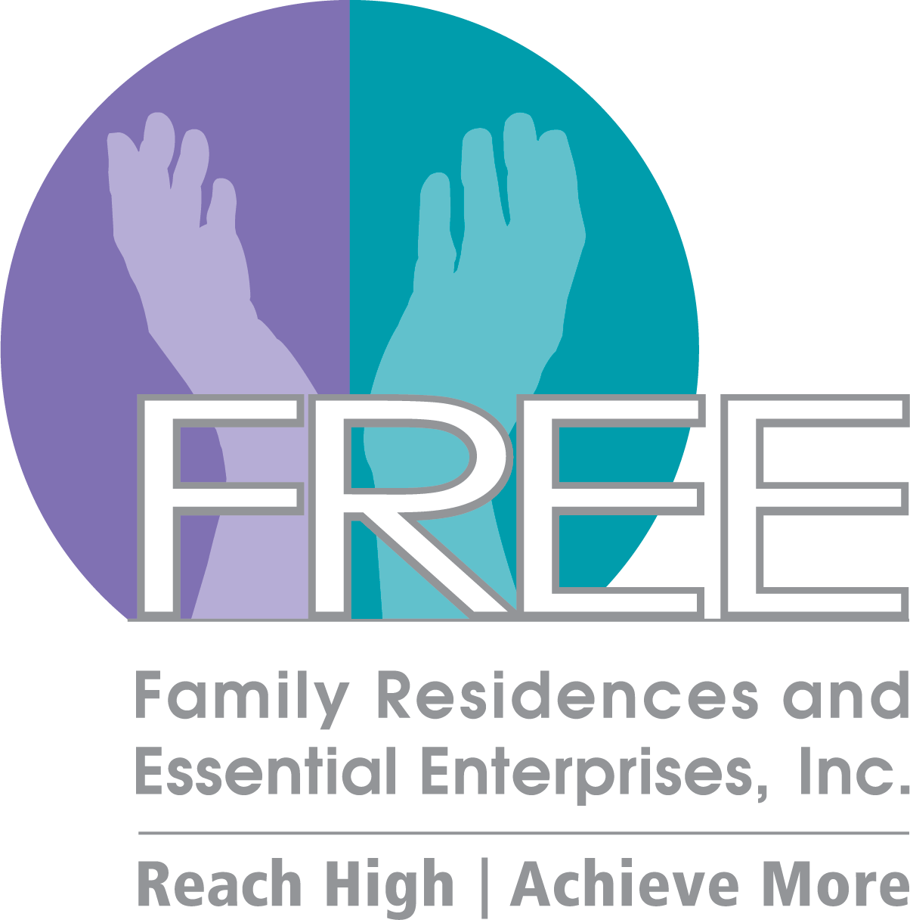

**08ioo**

**\*DISCLAIMER: Undisplayed organizational logos could not be found online**



**COVID-19 TESTING**

* <https://coronavirus.health.ny.gov/find-test-site-near-you>

**Announcements**

* The **CoC Business Meeting will resume virtually. Our next meeting will take place on September 25th.** Please refer to the CoC Newsletter and emails for monthly updates.
* The **CoC website** - **lihomeless.org** has a comprehensive list of resources pertaining to COVID-19 for people experiencing homelessness and their homeless service providers. There is also a list of food pantries which is updated regularly.
* All meetings will be online through Zoom
* **The 2020 Census is NOW OPEN** - The results of the 2020 Census will help determine how hundreds of billions of dollars in federal funding flow into

communities every year for the next decade. That funding shapes many different aspects of every community, no matter the size, no matter the location.

* + <https://2020census.gov/en.html>
* SAVE THE DATE! The 32nd Annual Keys for the Homeless Conference will be November 18th (Virtual Event)
  + Please direct questions to: [ymann/@addressthehomeless.org](mailto:ymann/@addressthehomeless.org) and [gguarton@addressthehomeless.org](mailto:gguarton@addressthehomeless.org)

**\*\*\*Please visit lihomeless.org for additional updates (food resources, testing centers, funding opportunities, training information, service provider resources, etc.)**

* <https://www.lihomeless.org/>
* <https://www.lihomeless.org/covid-19>
* <https://www.lihomeless.org/covid-19-hud-ta-and-local-guidance>

**AUG 2020**

**2020 CoC Schedule**

**\*March 20th, April 17th, August 14 – Governance Board Meeting Only\***

JUL 17

**\*AUG 14**

SEP 25

OCT 16

NOV 20

DEC 18

JAN 17

FEB 21

*MAR 20

*APR 17

MAY 15

JUN 19

*insert text*

**HUD TECHNICAL ASSISTANCE AND GUIDANCE**

* + <https://www.lihomeless.org/covid-19-hud-ta-and-local-guidance>

**HUD COVID-19 Office Hours Every Friday 2:30PM-4:00PM**

* + <https://www.hudexchange.info/news/office-hours-covid-19-planning-response-for-homeless-assistance-providers-fridays/>

**NYS UPDATES**

**Executive Orders**

* Website <https://www.governor.ny.gov/executiveorders>

**Eviction Moratorium**

* Extension – October 1st for eviction proceedings filed after March 17th
  + <https://files.constantcontact.com/3b9a3add001/d0efb93f-412b-4540-b4d9-3ae65b1c8edc.pdf>
  + <https://patch.com/new-york/new-york-city/ny-eviction-moratorium-extended-until-oct-1>

**Tenant Safe Harbor Act**

* <https://www.nysenate.gov/newsroom/press-releases/brad-hoylman/tenant-safe-harbor-act-sponsored-senator-brad-hoylman-signed>
* <https://www.nysenate.gov/legislation/bills/2019/s8192/amendment/b>

**RESOURCE SHARING**

* **Home Energy Assistance Program (HEAP) – Assists income eligible households pay for heat-related energy bills, even beyond the heating season, with a grant that clients do not have to pay back, deadline extended to August 31st** 
  + <https://www.ny.gov/services/apply-heating-and-cooling-assistance-heap>
* **SNAP Benefit Available for Long Islanders Who Lost Food Due to Power Outages (Deadline Extended)** 
  + New deadline for applications: September 4th
  + Please reach out to Health and Welfare Council of LI with any questions (516-483-1110)
* **Nassau Cooling Centers (Subject to change. Please visit and confirm with)** [**https://www.nassaucountyny.gov/4690/Warming-Cooling-Centers**](https://www.nassaucountyny.gov/4690/Warming-Cooling-Centers) **PRESS@NASSAUCOUNTYNY.GOV**
  + Cantiague Park Ice Rink [12PM-6PM]
  + Mitchel Field Complex [12PM-6PM]
  + Wantagh Park Community Center [12PM-6PM]
* **Suffolk Cooling Centers** 
  + Town of Babylon – Babylon residents can call the 24 hour public safety line if they require a cooling center (631-422-7600)
  + Town of Huntington – Dix Hills Ice Rink, Saturday-Thursday 6AM-8PM, Friday 6AM-10:30
  + Town of Huntington – Senior Beach House
    - Beach House (631-261-9186)
    - Cottage (631-261-1058)
    - Monday-Saturday: 10AM-4PM, Sunday: 12PM-5PM
  + Town of Huntington Senior Center: Monday-Friday 8:30AM-4:30PM
    - (631-351-3253)
  + Town of Riverhead – All town beach facilities will remain open with lifeguards until 7:00PM
  + Town of Shelter Island - Senior Center is open as a cooling center
    - (631-749-1059)
* **HALI Mobile Shower Unit – More information please contact: Tim Hankins, 631-234-1925 ext 374, to schedule an appearance in your location please contact: Alex Frisina afrisina@hali88.org**
  + West Islip Church of Christ – Mondays from 3PM to 5:30PM
  + Congregational Church of Patchogue – Wednesdays from 3:30PM-5:30PM
  + Saint Hugh of Lincoln Roman Catholic Church (Huntington Station) – Thursdays from 10AM-2PM
  + The Salvation Army Community Center (Riverhead) – Fridays from 10:30AM-1:00PM
* **New Food Pantries** 
  + <https://www.lihomeless.org/covid-19>

**Upcoming Webinars/Trainings**

1. **COVID-19 Response Meetings** 
   1. Every week/Every 2 weeks to discuss the planning and response in our region
   2. Updates on shelters, funding and supports for CoC and providers, resource sharing, etc
   3. Next meeting: June 5, 2020 at 10AM (WebEx Details Sent via Email)
2. **COVID-19 Office Hours Every Friday from 2:30PM-4:00PM**
   1. <https://www.hudexchange.info/news/office-hours-covid-19-planning-response-for-homeless-assistance-providers-fridays/>
3. **Keys for the Homeless Conference** 
   1. Anticipated virtual event for Fall 2020
   2. A survey will be sent out to assist with the planning of the event
      1. Workshop/Training Topics
      2. Suggestions for Trainers/Presenters
      3. The survey will also have questions pertaining to trainings you and your agency would like to see for the CoC

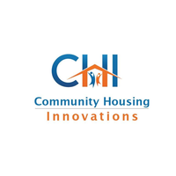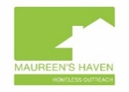

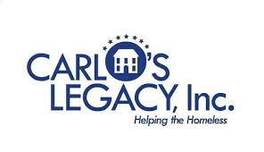









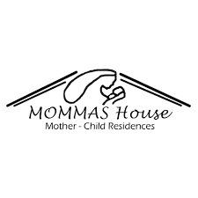

Suburban Housing

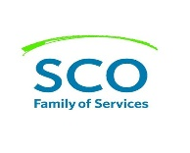

ADD/ADHD Housing Group INC.

**CoC Updates (General)**

**HMIS Updates**

* COVID-19 Awareness Screening Tool
  + Please continue to use (strongly encouraged)
* Emails/Inquiries
  + Please refer to [wscallon@addressthehomeless.org](mailto:wscallon@addressthehomeless.org) for all HMIS inquiries during this time

**Coordinated Entry System (LICH)**

* Next Case Conferencing Meeting
  + September 9th via Zoom 10:00AM-11:00AM
  + Meetings will occur bi-weekly due to the COVID-19 Prioritization
* COVID Prioritization
  + Effective: July 1st – September 1st and continuing September 1st to December 31st
  + Meetings to review prioritization will continue (last meeting August 18th)
  + Please see updated prioritization details: <https://www.lihomeless.org/coordinated-entry-prioritization>
  + Please refer to the CDC list of underlying medical conditions (subject to change, please check often)
    - <https://www.cdc.gov/coronavirus/2019-ncov/need-extra-precautions/people-with-medical-conditions.html?CDC_AA_refVal=https%3A%2F%2Fwww.cdc.gov%2Fcoronavirus%2F2019-ncov%2Fneed-extra-precautions%2Fgroups-at-higher-risk.html>
  + CE Steering Committee
    - For 2020, the CoC Governance Board has also delegated the CE Steering Committee as the entity that will also be responsible for the annual CE Evaluation process with CE operators, LICH and TSCLI.
    - Please submit your nomination form to [tpham@addressthehomeless.org](mailto:tpham@addressthehomeless.org) by September 2nd (close of business)

**Committee Updates**

* **Racial Equity Committee**
  + **NEXT MEETING: TBA Fall 2020 (Anticipated October)**
  + Advancing Racial Equity Through Assessments and Prioritization <https://files.hudexchange.info/resources/documents/COVID-19-Homeless-System-Response-Advancing-Racial-Equity-through-Assessments-and-Prioritization.pdf>
  + COVID-19 Racial Equity Resource Guide <https://www.lahsa.org/documents?id=4499-covid-19-racial-equity-resource-guide>
* **Legislation** 
  + **Bill 6874A –** This bill will give the Department of State the discretion to fine, suspend, or revoke the license of a real estate agent or broker who violates the state Human Rights Law, meaning realtors will be held accountable for any racially-biased behavior they exhibit while on the job
  + **Bill S6569 –** This bill will allow for appeals and even de novo trials (meaning the new court hearing the case does not refer to the original trial) in cases of housing discrimination that were dismissed by the Division of Human Rights for lack of probable cause or lack of jurisdiction

**Peace Valley Haven**