**LI CONTINUUM OF CARE MONTHLY NEWSLETTER**

**ISSUE**

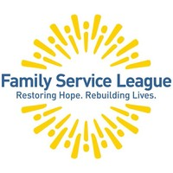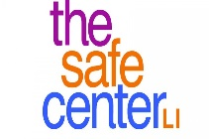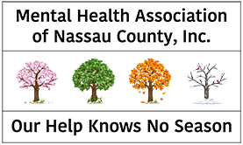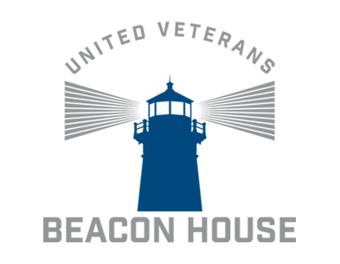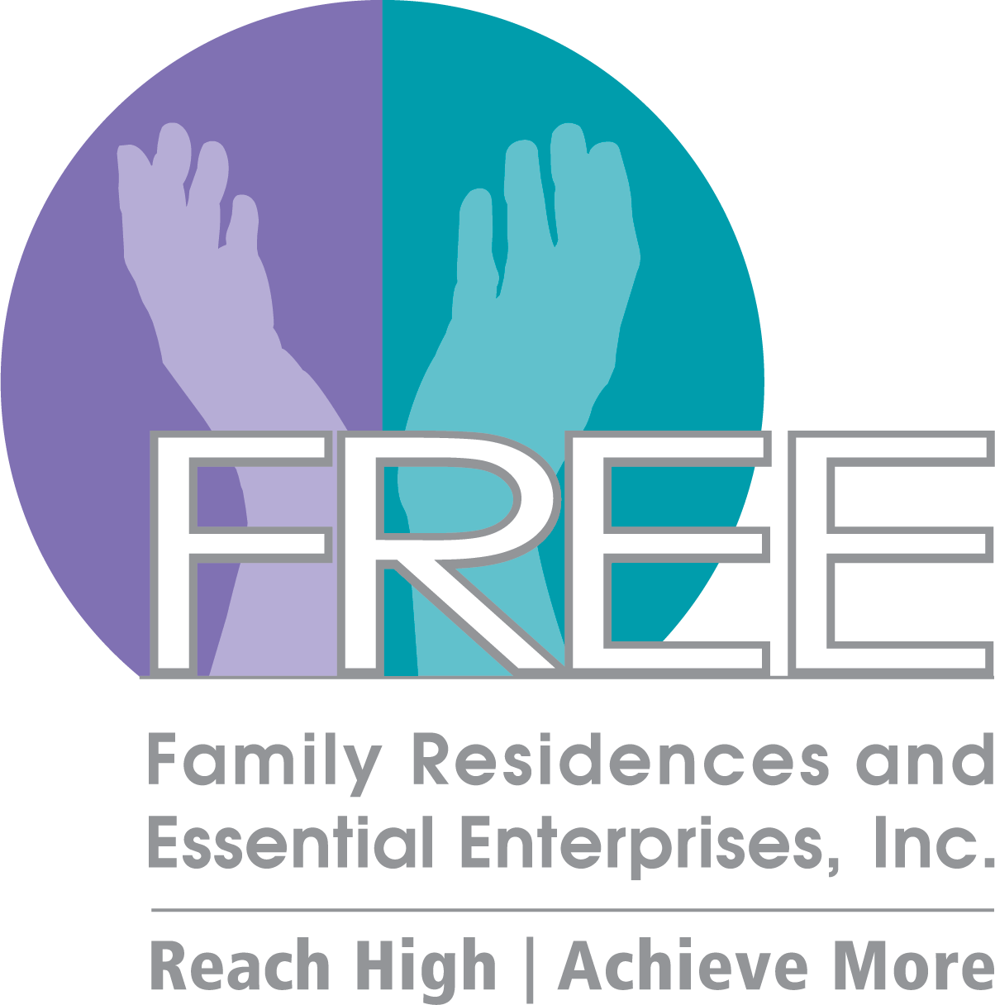

**09ioo**

**\*DISCLAIMER: Undisplayed organizational logos could not be found online**



**SEP 2020**

**COVID-19 TESTING**

* <https://coronavirus.health.ny.gov/find-test-site-near-you>

**Announcements**

* The **CoC Business Meeting will resume virtually. Our next meeting will take place on October 16th.** Please refer to the CoC Newsletter and emails for monthly updates.
* The **CoC website** - **lihomeless.org** has a comprehensive list of resources pertaining to COVID-19 for people experiencing homelessness and their homeless service providers. There is also a list of food pantries which is updated regularly.
* All meetings will be online through Zoom
* **The 2020 Census is EXTENDED** – Please encourage and assist your clients (if possible) to fill out their Census. The new date to submit your completed Census form is **Monday, October 5th** 
  + <https://2020census.gov/en.html>
* SAVE THE DATE! The 32nd Annual Keys for the Homeless Conference will be November 18th (Virtual Event)
  + Please visit our website for registration link/event schedule/list of workshop topics/and sponsorship information: <https://www.addressthehomeless.org/keys-conference>
  + Please direct questions to: [ymann/@addressthehomeless.org](mailto:ymann/@addressthehomeless.org) and [gguarton@addressthehomeless.org](mailto:gguarton@addressthehomeless.org)

**\*\*\*Please visit lihomeless.org for additional updates (food resources, testing centers, funding opportunities, training information, service provider resources, etc.)**

* <https://www.lihomeless.org/>
* <https://www.lihomeless.org/covid-19>
* <https://www.lihomeless.org/covid-19-hud-ta-and-local-guidance>

**2020 CoC Schedule**

**\*March 20th, April 17th, August 14 – Governance Board Meeting Only\***

JUL 17

**\***AUG 14

SEP 25

**OCT 16**

NOV 20

DEC 18

JAN 17

FEB 21

*MAR 20

*APR 17

MAY 15

JUN 19

*insert text*

**HUD TECHNICAL ASSISTANCE AND GUIDANCE**

* + <https://www.lihomeless.org/covid-19-hud-ta-and-local-guidance>

**HUD COVID-19 Office Hours Every Friday 2:30PM-4:00PM**

* + <https://www.hudexchange.info/news/office-hours-covid-19-planning-response-for-homeless-assistance-providers-fridays/>

**RESOURCE SHARING**

* **HALI Mobile Shower Unit – More information please contact: Tim Hankins, 631-234-1925 ext 374, to schedule an appearance in your location please contact: Alex Frisina afrisina@hali88.org**
  + West Islip Church of Christ – Mondays from 3PM to 5:30PM
  + Congregational Church of Patchogue – Wednesdays from 3:30PM-5:30PM
  + Saint Hugh of Lincoln Roman Catholic Church (Huntington Station) – Thursdays from 10AM-2PM
  + The Salvation Army Community Center (Riverhead) – Fridays from 10:30AM-1:00PM
* **New Food Pantries** 
  + <https://www.lihomeless.org/covid-19>
* **HIV Program – Options for Community Living** 
  + Please Contact Liz Brown – HIV Prevention Specialist at 516-481-6300 or email [ebrown@optionscl.org](mailto:ebrown@optionscl.org)
  + Options offers linkage to a variety of individualized support servuces for persons living with HIV/AIDS (PLWHA) or HIV negative persons engaging in high-risk behaviors. Linkages to available HIV services include:
    - PrEP and PEP – Transporation Coordination, Legal Support, Housing Services, Supportive Counseling, Education/Employment, Prevention Counseling, Primary Care, Partner Services, Overdose Prevention Training, Translation/Interpretation, Benefits/Entitlements, Treatment Education and Adherence
* **2020 PIT Count Numbers** 
  + Please visit our website: <https://www.lihomeless.org/pitcount>
* **COVID Alert NY Application (Free App for Download)** 
  + Alerts users if they have come into close contact – within 6 feet for at least 10 minutes, with someone who has tested positive for COVID-19 even before the app user may experience symptoms
  + Knowing about a potential exposure allows you to self-quarantine immediately, get tested, and reduce the potential exposure risk to your family/friends/neighbors/co-workers/and others

**Upcoming Webinars/Trainings**

1. **COVID-19 Response Meetings** 
   1. Every week/Every 2 weeks to discuss the planning and response in our region
   2. Updates on shelters, funding and supports for CoC and providers, resource sharing, etc
   3. Next meeting: June 5, 2020 at 10AM (WebEx Details Sent via Email)
2. **COVID-19 Office Hours Every Friday from 2:30PM-4:00PM**
   1. <https://www.hudexchange.info/news/office-hours-covid-19-planning-response-for-homeless-assistance-providers-fridays/>
3. **Keys for the Homeless Conference** 
   1. Anticipated virtual event for Fall 2020
   2. A survey will be sent out to assist with the planning of the event
      1. Workshop/Training Topics
      2. Suggestions for Trainers/Presenters
      3. The survey will also have questions pertaining to trainings you and your agency would like to see for the CoC

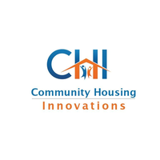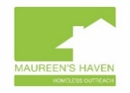

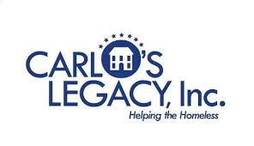









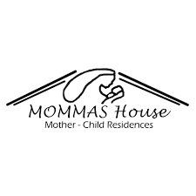

Suburban Housing



ADD/ADHD Housing Group INC.

**CoC Updates (General)**

**HMIS Updates**

* COVID-19 Awareness Screening Tool
  + Please continue to use (strongly encouraged)
* Emails/Inquiries
  + Roxzelle is back! Please refer your questions to rbannerman@addressthehomeless.org

**Coordinated Entry System (LICH)**

* Next Case Conferencing Meeting
  + October 7th via Zoom 10:00AM-11:00AM
  + Meetings will occur bi-weekly due to the COVID-19 Prioritization
* COVID Prioritization
  + Effective: July 1st – September 1st and continuing September 1st to December 31st
  + Meetings to review prioritization will continue (last meeting August 18th)
  + Please see updated prioritization details: <https://www.lihomeless.org/coordinated-entry-prioritization>
    - Prioritization: Inability to self isolate, AND immunosuppressed illness as per the CDC (subject to change, please check list often), AND presents high barrier/least likely to exit homelessness (homeless 1+ year, history of evictions that resulted in homelessness, and/or criminal history), within the identified COVID priority HHs – HHs are then prioritized and ordered by age
    - Please refer to the CDC list of underlying medical conditions (subject to change, please check often) <https://www.cdc.gov/coronavirus/2019-ncov/need-extra-precautions/people-with-medical-conditions.html?CDC_AA_refVal=https%3A%2F%2Fwww.cdc.gov%2Fcoronavirus%2F2019-ncov%2Fneed-extra-precautions%2Fgroups-at-higher-risk.html>
  + CE Steering Committee
    - Congratulations to those who were voted to represent the 2020 CE Steering Committee!
    - The Onboarding Process will begin in October 2020 (email will be sent to committee members)

**Trainings/Webinars (Past or Upcoming)**

* **Rapid Rehousing Trainings: TBA**
* **Legal Support Center for Advocates Presentation: Landlord Tenant Law and Eviction During the Pandemic (Hosted by Nassau Suffolk Law Services) on 9/25** 
  + Landlord Tenant Presentation and Handouts can be found:

<https://www.lihomeless.org/training-support>

* **Fair Housing and Housing Discrimination Training (Hosted by LICH and Long Island Housing Services on 9/24** 
  + This training will provide a history of fair housing and the federal, state and local fair housing laws.  The training will include the different types of housing discrimination that are prevalent in Long Island, including racial discrimination, discrimination against individuals with disability, and source of income discrimination. Participants will learn to identify and report housing discrimination, including how to file a complaint.
  + Recorded training and powerpoint slides: <https://www.lihomeless.org/training-support>
  + There will be more trainings in the near future – TBA via email
* **Community Investment and Planning (CIP) Training (Hosted by LICH and ICF) on 9/21 and 9/22**
  + Recorded training and powerpoint slides can be found: <https://www.lihomeless.org/covid-19-hud-ta-and-local-guidance>
  + This meeting was led by the ICF team, with input from Nassau County Community Development, Town of Brookhaven and Suffolk County DSS. LICH staff will also be on hand to discuss coordinated entry and HMIS requirements for these programs.
  + Topics covered:
    - Program models designed to prevent, prepare for, and respond to the coronavirus/Targeted Homelessness Prevention program models/Robust RRH models that include housing-based case management and landlord engagement/ Program models that advance racial equity through targeting and engagement of non-traditional ESG partner organizations/Program models that provide housing-based street outreach/Program models that provide housing-based case management and diversion in an emergency shelter

**Committee Updates**

* **Racial Equity Committee**
  + **NEXT MEETING ANTICIPATED: November 5, 2020 at 3PM**
  + We will discuss: Regional racial disparities, ESG-CV planning with a focus on racial equity, and National Alliance to End Homelessness – Centering Racial Equity in Housing Needs and Community Response to Enact Social Change PowerPoint

**Peace Valley Haven**