**LI CONTINUUM OF CARE MONTHLY NEWSLETTER**

**ISSUE**

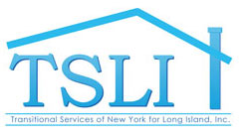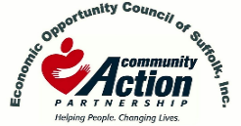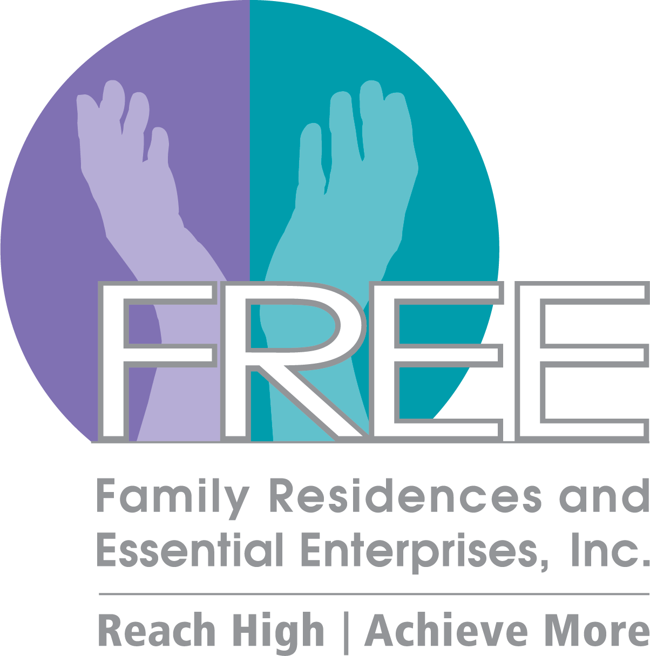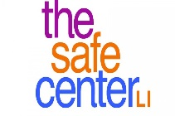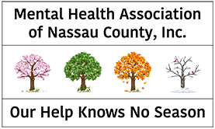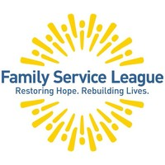 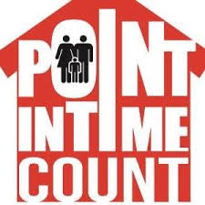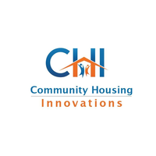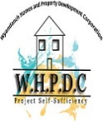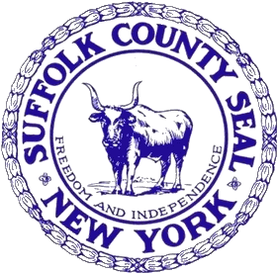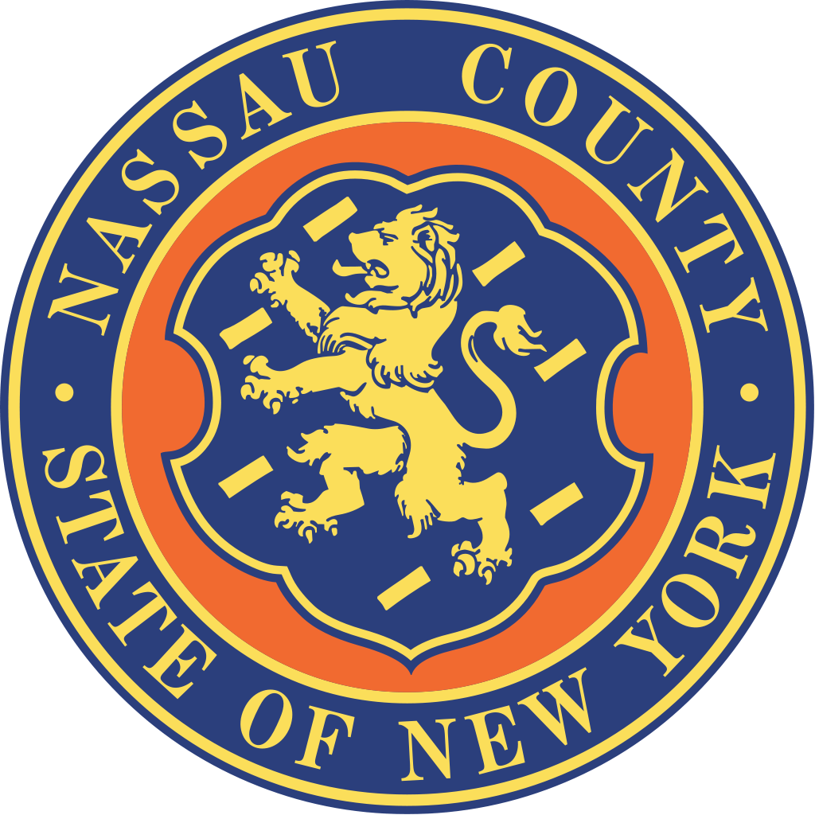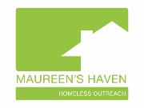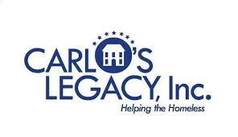

**Committee Updates**

**Racial Equity Committee**

* First Meeting was on 2/12
* Minutes can be found on lihomeless.org under the “About” tab in the “Racial Equity Committee” drop-down
* Next Steps: Need more educational items/trainings for local brokers, Need to identify real estate laws
* Next Meeting: TBA via email

**Youth and Young Adult Services Committee**

* Recap of Youth/Young Adult PIT Count
* McKinney-Vento statistics regarding school districts with the highest number of youth homelessness can be found on nysteachs.org
* Resource Guide in english and spanish can be found on the lihomeless.org website under the “About” tab in the “Youth and Young Adult Services Committee” drop-down
* Implementing Change: Addressing the Intersections of Juvenile Justice and Youth Homelessness for Young Adults (An overview of youth homelessness and youth who enter the juvenile justice system and how to address and work with those particular individuals) <https://www.juvjustice.org/sites/default/files/resource-files/Implementing%20Change%20-%20Juvenile%20Justice%20and%20Youth%20Homelessness.pdf>

**JUL17**

**\*AUG 14**

**SEP 25**

**OCT 16**

**NOV 20**

**DEC 18**

**JAN 17**

**FEB 21**

**MAR 20**

**APR 17**

**MAY 15**

**JUN 19**

**2020 CoC Schedule**

**\*August 14 – Governance Board Meeting Only**

**\*DISCLAIMER: Undisplayed organizational logos could not be found online**

**FEB 2020**

*insert text*

**01ioo**

**PIT Summaries**

**Homelessness on Long Island in 2020**

**\*(Based on Initial Raw Data Pending Review)**

**Household Breakdown**

**31% Single Adults**

**69% Families**

**On a given night in January, there were 3,787 people experiencing homelessness on Long Island**

Suburban Housing

ADD/ADHD Housing Group INC.

**Data on Homelessness in the Region**

**Upcoming Webinars**

1. Youth Collaboratory: 2020 Federal Funding Webinar

* **Date: February 27, 2020; 2:00 p.m. ET**
* **Registration Link:** <https://youthcollaboratory.force.com/s/lt-event?id=a2K4p000003R44bEAC>

1. The 2019 State Index on Youth Homelessness Webinar

* **Date**: Able to watch anytime
* **Link:** <https://www.youtube.com/watch?v=fdiSeJufdw4&feature=youtu.be>

**Upcoming Events**

1. The Town of Brookhaven Youth Bureau and Suffolk County Probation Department: Gangs on Long Island What you need to know…

* **Date**: Monday, March 23rd 9:00-11:30 AM
* **RSVP** by March 16th by calling 631-451-8011
* **Location**: Brookhaven Town Hall

1 Independence Hill Second Floor Media Room

Farmingville, NY 11738

**Peace Valley Haven**